**Name: Session:**

**Programming II**

**Lab Exercise 1.28.2022**

**Complete the following programs. When you have completed each program, submit a copy of your documented source code. Your documentation should include at a minimum name, assignment number (i.e. Lab Exercise 1.28.2022 Problem 1) and a sample output of your program run.**

1. Write a C# program that declares variables to represent the length and width of a room in feet and the price of carpeting per square foot in dollars and cents. Assign appropriate values to the variables. Compute and display, with explanatory text, the cost of carpeting the room. Save the program as Carpet.cs
2. Write a program that declares four variables to hold the number of eggs produced in a month by each of four chickens, and prompts the user for the number of eggs for each chicken. Sum the eggs, then display the total in dozens and eggs. For example, a total of 127 eggs is 10 dozen and 7 eggs. Save the program as Eggs.cs.
3. Write a program that declares five variables to hold scores for five tests you have taken, so it accepts five test scores from a user. Display the average of the test scores to two decimal places. Save the program as Tests.cs.
4. Write a program that prompts the user for a name, Social Security number, hourly pay rate, and number of hours worked. In an attractive format (as shown below), display all the input data as well as the following:

• Gross pay, defined as hourly pay rate times hours worked

• Federal withholding tax, defined as 15% of the gross pay

• State withholding tax, defined as 5% of the gross pay

• Net pay, defined as gross pay minus taxes

Save the program as Payroll.cs.

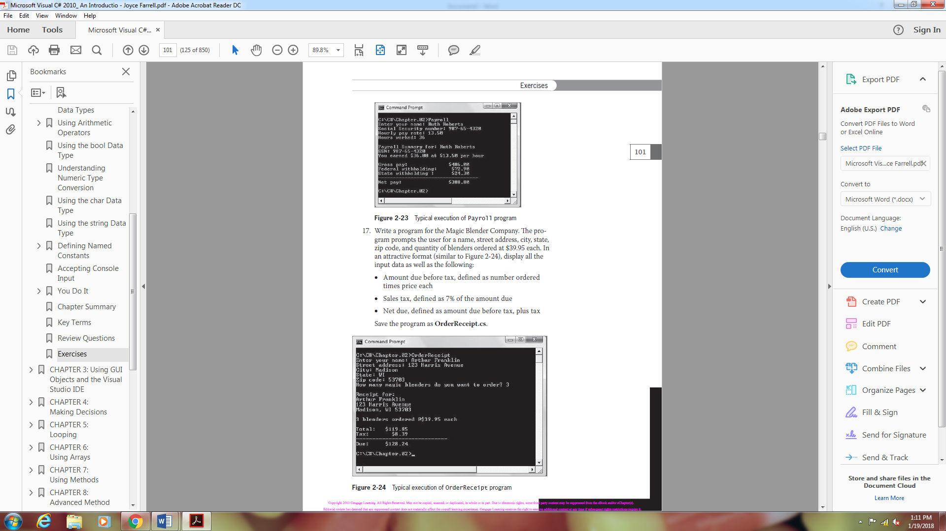

1. Write a program for the Magic Blender Company. The program prompts the user for a name, street address, city, state, zip code, and quantity of blenders ordered at $39.95 each. In an attractive format (as shown below), display all the input data as well as the following:

• Amount due before tax, defined as number ordered times price each

• Sales tax, defined as 7% of the amount due

• Net due, defined as amount due before tax, plus tax

Save the program as **OrderReceipt.cs**.

